Prayer Service details for Christmas
There are Prayer Services in each of the Grow in Love books for the Christmas season. As some children may not get to attend church services this Christmas, due to the Covid pandemic, we urge all teachers to celebrate these prayer services with their respective classes.
They can be found in the Teachers’ Manuals as follows:
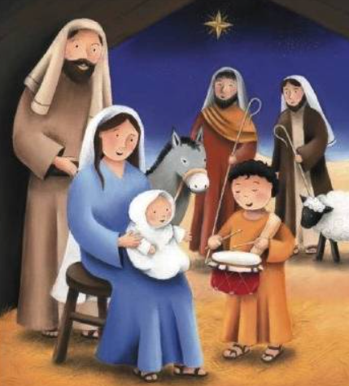
Junior Infants : Page 100
Senior Infants: Page 111
First Class: Page 108
Second Class: Page 116
Third Class: Page 151
Fourth Class: Page 156
Fifth Class: Page 167
Sixth Class: Page 194

