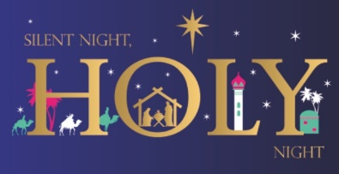
Christmas------did you know?
- The Christmas carol, Silent Night, was first performed on Christmas Eve in 1818 in the Church of St. Nicholas in Oberndorf, a village in Austria.
(4th Manual p. 152).
- St. Francis of Assisi introduced the very first Christmas Crib in 1223. It happened in a place called Greccio, about halfway between Assisi and Rome. (3rd Class Manual, p. 148).
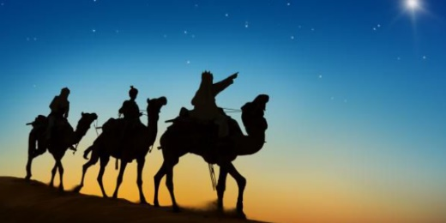
- The word “angel” comes from the Greek word “angelos” which means messenger from God. (3rd Class manual, p. 144)
- Traditionally, the Three Wise Men are named Caspar, Melchior and Balthasar, but these names are not mentioned in the Bible. These names emerged in later Christian tradition. (4th Class Manual, p. 152)
- The Magi (meaning learned people) is another name for the Three Wise Men, who followed the star to the stable in Bethlehem, where they found the baby Jesus with his parents, Mary and Joseph.
- 6. St. Stephen’s Day is celebrated on December 26th. Stephen, the first martyr, was stoned to death for his belief in Jesus as the Son of God. In some countries, December 26th is called Boxing Day.
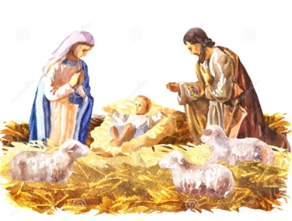
- December 26th is known as Boxing Day in Europe since the Middle Ages. Collection boxes, which were left in churches during Advent, now full of food and clothes, donated by the wealthy, were opened on December 26th. Hence, Boxing Day. In Ireland, the landlords gave a box of “goodies” to their tenants and there was much merry-making and celebrating.
- We are all familiar with the Twelve Days of Christmas. It begins with “On the first day of Christmas, my true love gave to me, a partridge in a pear tree”. If you receive all the gifts in the song, you would get 364! Count them to be sure!
- The custom of sending Christmas cards, as we know them today, was started in the UK by Sir Anthony Cole in 1843. He was the “brains” behind setting up the national postal service in England. Stamps cost 1d (old penny) and could be sent to cities all over England on the newly established train services.
- Early records show that a large candle, representing the Star of Bethlehem, was lit during the dark days of winter. In Ireland, the people lit a large red candle and placed it on their window sills as a sign of welcome to anyone passing by. Candles are also lit during the Feast of Hanukkah, the Jewish festival of lights, which is also celebrated at this time of year.

