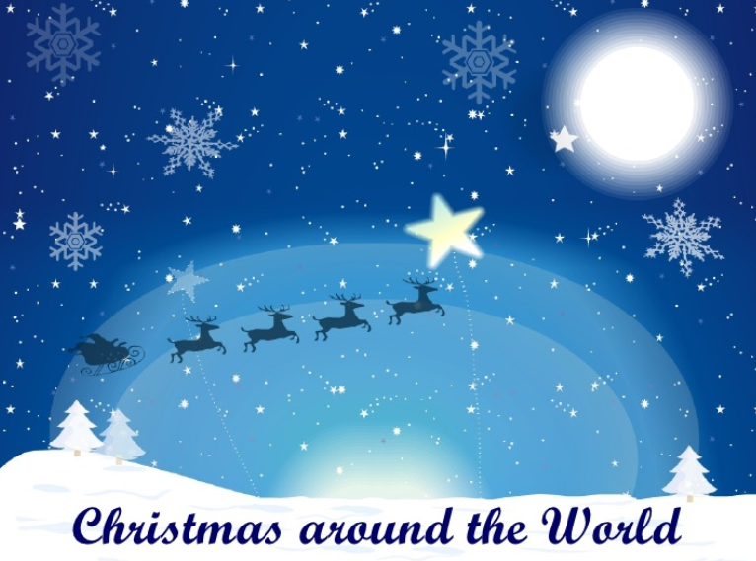

(Based on facts in 5th Class Grow in Love Teachers’ Manual, Pages 173-174)
Match these appropriately:
- St. Nicholas Grotto of the Nativity

- Wigilia a service in Australia

- Mexico Santa’s name in China

- Dun Che Lao Ren Feast of the Epiphany

- Carols by candlelight lived in Hungary

- Celebrated widely in Brazil to show Jesus as light of the world

- Christmas in Japan celebrated with many choirs singing

- Small lamps on the rooftops in people visited their family graves southern India

- Around Christmas time in Finland people roller skate to Mass

- In Bethlehem a time to spread happiness

- Christmas in the Congo Christmas eve meal in Poland

- In Caracas, Venezuela a special celebration in Mexico

