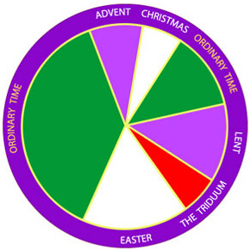

The Liturgical Year

The Liturgical Year  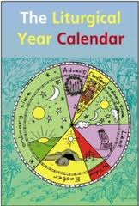 | The Seasons of the Church’s year form the Liturgical Year. This is because each season has a particular designated Liturgy for that season which is based on the Church’s celebration of the life of Christ. Some of the seasons are times of preparation and reflection, others times of joy and celebration and some times of sorrow.  The Year begins on the First Sunday of Advent and ends on the Feast of Christ the King.  Colour is used to mark each season. The vestments worn by the priest and which adorn the altar are changed according to the colour of that season.  Ordinary time = green (a colour symbolic of life and growth),  Easter and Christmas = white (the colour used for celebration),  Advent and Lent = purple (the colour for times of preparation).  Red, although not the colour of a season, is used on individual days such as Pentecost and on the feasts of martyrs (those who were put to death for the faith).  Rose vestments are worn on Gaudete Sunday (3rd Sunday of Advent) and Laetare (4thSunday of Lent).  These are days within times of preparation to remind us of the celebration which is approaching.
Holy Days of Obligation  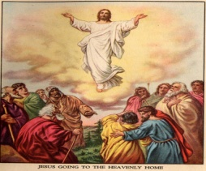 | These are the days when Catholics are obliged to go to Mass.  All Sundays are holydays (the Saturday vigil Mass counts as Sunday Mass). Sundays are known as the Lord’s Day and it is on this day of the week that we celebrate his resurrection.  There are ten other holy days. Each country decides which are to be celebrated. Two of these days have been moved from a specific date to a Sunday namely: The Ascension and Corpus Christi. These are known as moveable feasts because the date of the celebration changes each year.  Other holy days which are celebrated on the date they fall (immoveable feasts) are: -  - The Feast of the Immaculate Conception (8th December),  - The Birth of the Lord (25th December),  - Saint Patrick's Day (17th March),  - The Assumption (15th August) and  - All Saints (1st November).  A Liturgical Calendar is published each year which identifies the days of the year, what the readings are and what colour the vestments should be. This is available to buy in Veritas.
Solemnities  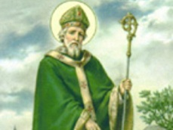 | Solemnities are days on which significant events or people in the Church’s history are commemorated. Funerals are not permitted on these days.
Feasts  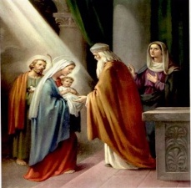 | These are the days on which specific saints or moments in the life of Christ e.g. Presentation of the Lord, are commemorated. Again these days are not holy days of obligation and carry less importance than solemnities. When these feasts fall on a weekday, Mass will have specific readings and the Gloria will be said or sung during Mass. Note: feast days are not festivals as understood in some other world religions.
Memorials  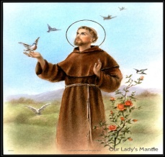 | Memorials are days when we commemorate saints in the universal Church and those which are particular to each diocese. The Mass will be an ordinary week day Mass e.g. St. Francis of Assisi. Here in Tuam, we celebrate the feast of St. Jarlath, who is the patron saint of our diocese, on June 6th every year.
Feria  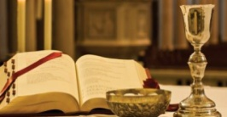 | A feria is an ordinary day of the week which has not been assigned to anything. The readings for the Mass would be the readings of the day.
Advent | Advent is the season in which we prepare for the birth of Jesus.  Advent begins four Sundays before Christmas Day (25th December) on the Sunday nearest to the 30th of November.  The first day of Advent is also the first day of the Liturgical Year.  The liturgical colour for the season is purple.  The candles on the Advent Wreath represent the weeks in which we prepare to celebrate the birth of Jesus. Three of the candles are purple whilst the candle used for the third week of Advent is pink. This is used to mark Gaudate Sunday which means rejoice Sunday. The ring of evergreen is symbolic of God’s everlasting love which, like a ring, has no beginning and no end.  Advent calendars are used to count down the days until Christmas. Note that most contemporary calendars only count down the days in December.
Christmas  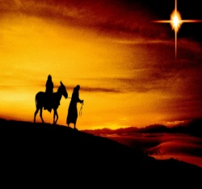 | The season which celebrates the birth of Jesus. The Liturgical colour for this season is white. The Christmas season begins with the vigil Mass on Christmas Eve and ends on the Feast of the Baptism of Jesus (the Sunday after the Epiphany).
Christmas Day  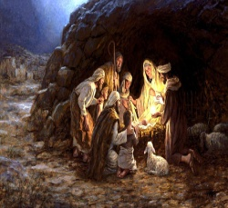 | Christmas Day is the 25th December and is the day on which we celebrate the birth of Jesus. Jesus, God in human form, Emmanuel [God with us], is revealed firstly to the people of Israel i.e. to the shepherds who are his first visitors.  Christmas Day is traditionally the day on which we exchange gifts here in Ireland. In other parts of Europe the exchange of presents may take place on Christmas Eve, the Epiphany or the 6th December – St. Nicholas' Day.
Epiphany  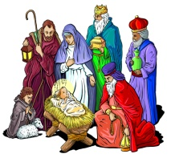 | The Epiphany is celebrated on the 6th January.  The word epiphany means a ‘sudden realisation’. The Epiphany celebrates the visit by the wise men to the stable to honour Jesus. Jesus, God in human form, is revealed to the whole world i.e. to the three wise men.  The gifts brought by the wise men are symbolic:  gold = Jesus’ royalty, he is our king;  frankincense = Jesus’ divinity, he is God;  myrrh = Jesus’ passion and death (myrrh being incense used for the dead).
Baptism of our Lord  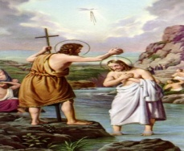 | Jesus’ baptism in the river Jordan by his cousin John the Baptist is celebrated on the Sunday after the Epiphany. This is the last day of the Christmas season.
Lent  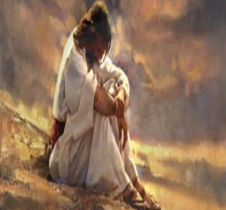 | Lent is the season of preparation which precedes Easter. It lasts for 40 days starting on Ash Wednesday and ending on the Wednesday of Holy Week. The six Sundays which fall in Lent are not included in the 40 days. This is because Sundays of Lent are like every other Sunday, a celebration of the Resurrection. The word ‘lent’ means lengthening of the days and Lent occurs when the days are getting longer.  The colour of the season is purple. The 40 days are symbolic of the 40 days Jesus spent fasting and praying in the desert in preparation for his ministry. Lent is a time for prayer, fasting and almsgiving and for us to grow closer to God and to our neighbour.  During the season of Lent parish communities will participate together in a number of activities relating to prayer (e.g. Stations of the Cross, reconciliation services, additional personal prayer), fasting (giving up chocolate, sweets, alcohol for the whole of Lent or giving of yourself – your time, your skills and sharing your talents) and almsgiving (fund raising and charitable action).  During Lent we do not sing or say the word ‘Alleluia’ nor do we sing or say the Gloria at Mass.
Shrove Tuesday (Pancake Day) | Shrove comes from the verb to shrive which means to hear confession, give penance and absolution. Lent is a time when Christians seek forgiveness for their sins.  Traditionally no rich foods such as eggs, milk and sugar were eaten during Lent. The easiest way to use them up was by making pancakes and thus the tradition of eating pancakes has arisen. This day is also seen as the last chance for feasting before the solemn season of Lent begins.  In other parts of the world different names are given to this day: Mardi Gras, Fat Tuesday. Note that the word ‘carnival’ means goodbye to meat.
Ash Wednesday  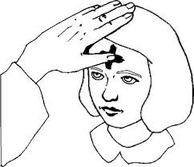 | This is the first day of Lent. Christians attend either Mass or a Liturgy and receive the ashes. The ashes are made from the Palm Leaves from Palm Sunday of the previous year. The Liturgical colour is purple.  The ashes are placed on the forehead in the shape of the +. The person distributing the ashes will say “Repent and believe in the Gospel” which means we should say sorry for all our failings and try to live as Jesus teaches us in the Gospel.  Wearing ashes dates back to Old Testament times. Penitents (those seeking forgiveness) would wear sackcloth and ashes.  Ash Wednesday is a day of fasting and abstinence.
Holy Week  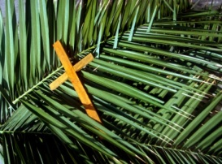 | Holy Week begins on the 6th Sunday of Lent known as Palm Sunday and ends on the Saturday vigil. It is the week before Easter where Jesus’ last days are commemorated.  Images of the cross and statues in the Church may be veiled from the 5th Sunday of Lent or the beginning of Lent.
Palm Sunday  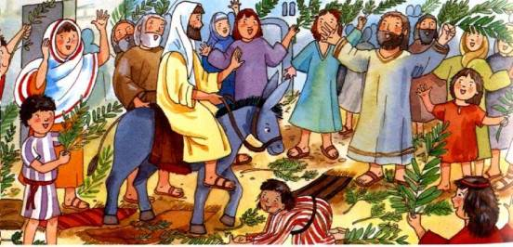 | Jesus’ triumphant entry to Jerusalem is remembered on this day. Palm leaves or palm crosses are given to the congregation to remind us of the palm leaves waved by the crowd greeting Jesus.  This Mass begins at the back of the Church where the Gospel about Jesus’ entry into Jerusalem is read. A procession to the altar then takes place during which the people hold their palms as they join in with the psalm or suitable hymn proclaiming Jesus as king. The Mass then proceeds from the opening prayer. The Gospel reading which now takes place is the full account of Jesus’ passion from the Last Supper to his burial in the tomb. Unlike other Sundays when the priest or deacon reads the Gospel, on this day a number of readers will take the parts of those in the reading. In this way Palm Sunday sets the scene for the rest of the week which will focus on the unfolding of the story of Jesus’ passion and death in more detail as the week progresses.  Red vestments are worn on Palm Sunday.
Chrism Mass  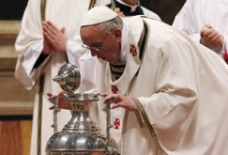  Pope Francis blesses the oil. | This Mass takes place in the cathedral of each diocese where the oils to be used in the Sacraments are blessed by the bishop and distributed to the clergy. It is on this day that the priests of the diocese renew their promises of Ordination in the presence of the Bishop  Traditionally this Mass is celebrated on Holy Thursday and in the Archdiocese of Dublin it takes place in the Pro-Cathedral.
Easter Triduum  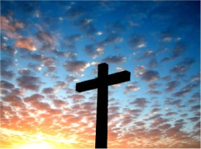 | A triduum is a three-day event. The Easter Triduum begins on Holy Thursday at the Evening Mass of the Lord’s Supper and lasts until the evening of Easter Sunday. It centres upon Jesus’ passion, death and resurrection.
Holy Thursday  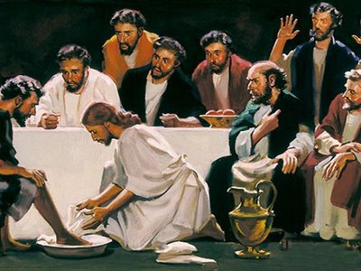 | On this evening the Last Supper is commemorated. During the Mass the priest washes the feet of twelve members of the congregation just as Jesus washed the disciples’ feet to teach us that we are to serve one another. The central focus of this ceremony is upon the institution of the Eucharist. Jesus’ instructions to his disciples “Do this in memory of me” are at the heart of the Mass. What was the Last Supper for the disciples has become the Eucharist for us.  Mass is followed by procession of the Blessed Sacrament to the altar of repose, where watching at the altar may continue until midnight. This commemorates Christ’s agony in the garden and arrest.  In the main Church the altar is stripped and the tabernacle is emptied. The church bells will have been silenced after the Gloria at the Mass and will not ring again until the Gloria at the Easter Vigil Mass.  Holy Thursday is also known as Maundy Thursday by other Christians. The word Maundy derives from the Latin phrase ‘mandatum novum’ which refers to the new commandment Jesus gave to his disciples at the Last Supper i.e. “love one another as I have loved you” (John 13: 34).
Good Friday  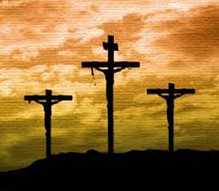 | Good Friday is the day on which Jesus’ passion and death are commemorated. Mass is not celebrated on this day. Commemoration of the Stations of the Cross takes place at twelve noon in many parishes. The Liturgy on Good Friday commences at three o’clock, the time at which it is believed Jesus died. In the liturgy we listen and participate in the story of the Passion just as we did on Palm Sunday. Then Veneration of the Cross takes place where the people kiss the crucifix as an acknowledgement of the sacrifice made by Jesus. The liturgy ends with the receiving of Holy Communion.  Good Friday has always been a day of fasting. Hot Cross buns are traditionally eaten because of the cross to remind us of Jesus’ death and because they were a specific weight the people would not exceed their food allowance for the day.
The Easter Vigil  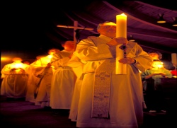  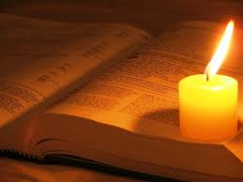  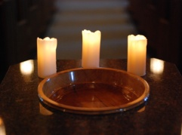  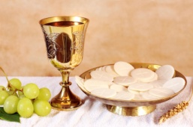 | The Easter Vigil takes place on Saturday evening and is in four parts.  Part 1: Service of Light: A fire is lit outside the Church and is blessed. The Easter Candle is prepared marked with a cross, the Greek letters alpha and omega and the numerals for the current year. Five grains of incense to represent Christ’s wounds are also inserted into the candle. The candle is then lit from the fire. A procession to the altar with the lighted candle now takes place.  Part 2: Liturgy of the Word: The Liturgy of the Word begins with seven readings and psalms from the Old Testament. These readings recall how God saved his people through history and in the fullness of time sent his own son to be our redeemer. After the last Old Testament reading the Gloria is sung and the opening prayer of the Mass of Easter Night is said. The Liturgy of the Word continues with the reading of the Epistle of St. Paul to the Romans about Baptism and the proclamation of the Gospel of the resurrection.  Part 3: Liturgy of Baptism. At this point the font in the church is blessed. This is followed by the celebration of Baptism and the renewal of baptismal promises for all those already baptised. During this part of the ceremony baptised Christians from other denominations may be received into full communion with the Catholic Church. The celebration of Confirmation can also take place at this point.  Part 4: Liturgy of the Eucharist
Easter  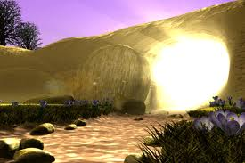 | Easter is the season which celebrates Jesus’ resurrection. It begins on Easter Sunday and lasts for 50 days ending on Pentecost Sunday.  The colour for this joyful season is white.  Many of the symbols and traditions which surround Easter focus upon new life e.g. Easter Eggs are symbolic of the tomb in which Jesus lay.
Easter Sunday  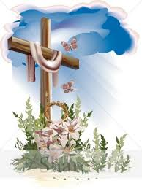 | Easter Sunday is the most important feast of the whole year. At Mass the congregation renew their Baptismal promises and are sprinkled with Holy water. This reminds us that it is through baptism we share in Jesus’ resurrection.
Month of Mary  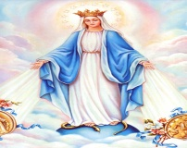 | May is the month we devote to Our Lady, the mother of Jesus.
The Ascension  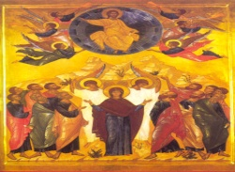 | This day commemorates when Jesus ascended to Heaven forty days after his resurrection. It is on this day Jesus promises to send the Holy Spirit to the disciples.
Pentecost  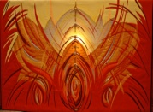 | This is the day on which the coming of the Holy Spirit to the disciples is remembered. It takes place 50 days after Jesus’ resurrection. Red vestments are worn on this day.
Sacred Heart 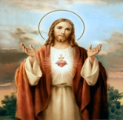 | June is the month devoted to the Sacred Heart of Jesus.
Corpus Christi 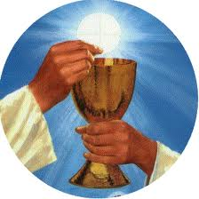 | Corpus Christi means body of Christ. It is on this day that we celebrate the gift of Jesus as the Blessed Sacrament. Traditionally outdoor processions were held where the Blessed Sacrament is carried in the monstrance as the people process behind singing hymns and saying prayers.
The Rosary 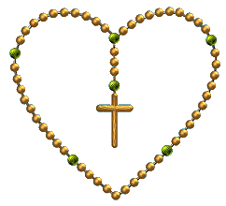 | October is the month devoted to the Holy Rosary.
All Saints  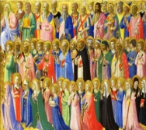 | This holy day falls on the 1st November and we commemorate all the saints in heaven, those known and unknown. All Saints Day is followed by All Souls Day. Although not a holy day it is the day on which we remember all those who have died.  The whole of the month of November is devoted to remembering and praying for all who have died. The “Eternal Rest” is the prayer used especially at this time.
Christ The King. 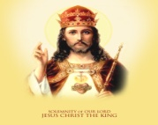 | This is the last Sunday of the Church’s year.

