ADVENT---------------------- ISAIAH IS AN IMPORTANT VOICE
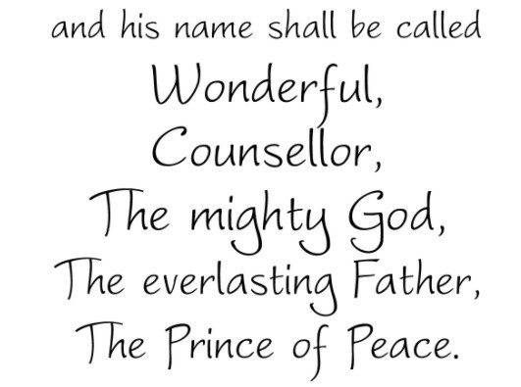
We are familiar with prophets from the Old Testament. A prophet is a person God chooses to announce His message. Israel had many prophets. Isaiah was one of the most famous of them. He lived about 700 years before the birth of Jesus.
Isaiah had to bring a hard message to the Israelites. They had stopped believing in the One, True God. They had stopped following God’s laws. Isaiah told them that they had to change their ways or they would experience great suffering.
Isaiah also had a happy message for them. He told them that God had promised to never stop loving them. When the time was right, God would send them a gentle and loving servant to lead them. Now, we know that the servant is Jesus.
Most of his prophesies were in poetry. His writings are quoted more than 50 times in the New Testament. This is what he said about the coming Messiah:
“A child is born to us! A son given to us! And he will be our ruler. He will be called, “Wonderful Counsellor, Mighty God, Eternal Father, Prince of Peace.” His royal power will continue to grow; his kingdom will always be at peace. He will rule as King David’s successor, basing his power on right and justice, from now until the end of time. The Lord Almighty is determined to do all this.”
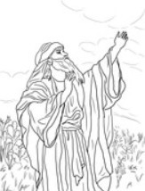
Use your dictionary to explain these words:
Counsellor, eternal, successor, determined.
Understand it
Kings are sometimes given special names that tell us what they are like. A king in England was called Richard, the Lion-Hearted. He was very brave.
A prince in Russia was called Ivan the Terrible. He was very cruel and mean.
The prophet Isaiah told the Israelites that a new king was coming. Isaiah gave this new king special names to describe what he would be like. He would be wonderful. He would be a counsellor, or give good advice. He would be a Prince of Peace. We know that the king whom Isaiah was describing was Jesus, the king who cares for the world forever.
Exercise:
Draw and colour a picture of Jesus as a king. Include one of the titles from Isaiah in your drawing.
ADVENT-----Another important voice: JOHN THE BAPTIST
Mark Ch 1: 4-8
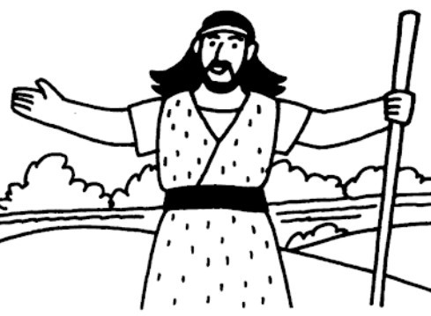
“So John appeared in the desert, baptising and preaching. “Turn away from your sins and be baptised”, he told the people, and God will forgive your sins. Many people……went out to hear John. They confessed their sins, and he baptised them in the River Jordan. John wore clothes made of camel’s hair, with a leather belt around his waist, and his food was locusts and wild honey. He announced to the people, “The man, who will come after me, is much greater than I am. I am not good enough even to bend down and untie his sandals. I baptise you with water, but he will baptise you with the Holy Spirit.”
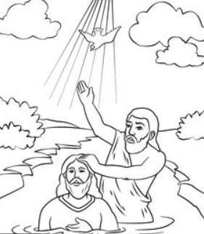
Understand it!
- We prepare our house when special visitors are coming----- cleaning, washing and preparing food. We put on our good clothes.
- When Jesus came to earth, God sent John the Baptist to prepare for Him. In this Bible story from Mark’s Gospel, John tells us to get ready, to admit our failings and stop sinning.
- He baptised his followers in the River Jordan as a sign that they wanted to change their ways.
- John also told the people that Jesus was coming. John explained that Jesus is far, far greater than he is.
- He told them that the Baptism Jesus would give would be much more powerful than his. Later on, Jesus was baptised by John in the River Jordan.
- This is the Baptism we received. It washed away our sins and made us members of the Church, the family of God.
Deliver us, Lord, from every evil and grant us peace in our days, as we wait in JOYFUL HOPE for the coming of our Saviour, Jesus Christ.
Prayer: Say this prayer to tell God you are sorry for your sins
O my God, I thank you for loving me. I am sorry for all my sins, for not loving others and not loving you. Help me to live like Jesus and not sin again.
Draw a picture of John the Baptist preaching and baptising in the River Jordan.

