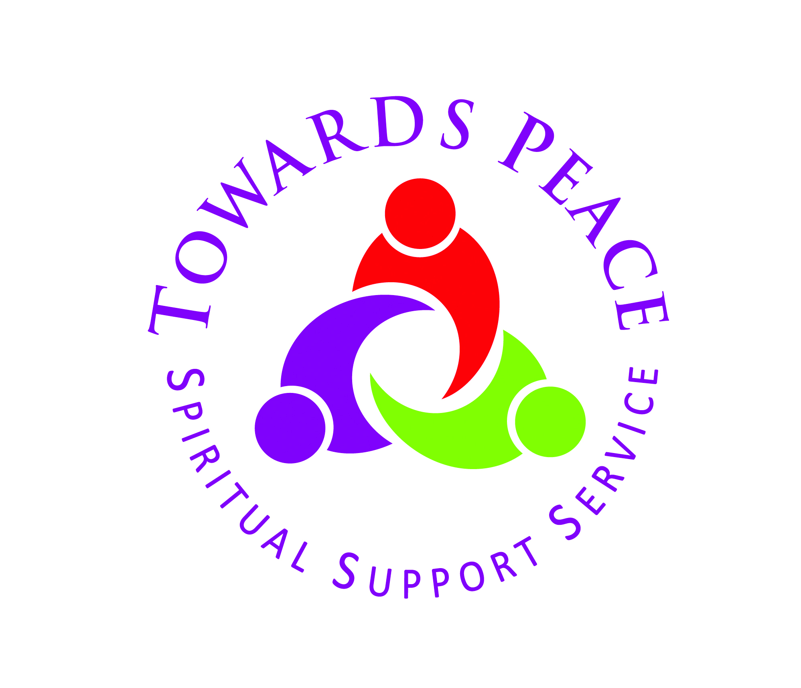
You are cordially invited to attend
the launch of
TOWARDS PEACE
in
KNOCK HOUSE HOTEL
on
Tuesday June 3rd at 7.00 p.m.
Followed by light refreshments

R.S.V.P. – Fr. Fintan Monahan at 093-24166 or archdiocesetuam@gmail.com before Friday, May 30th

